**Clinic Appointment Scheduling Application**

**Team members**

Jie Zhou, Nataliia Buchovska

**Project Description**

Our goal is to develop an appointment scheduling application which could be used at medical clinic. It will let the patients to schedule/reschedule/cancel the appointments with doctors conveniently. The doctors will also benefit from the application by managing their time efficiently.

Patients prescriptions will be accessible in the application. So, the patient can save/print his/her prescriptions.

The application will recommend the time the doctor is available. So, the patient can pick the best option.

Our application will ensure there is no double booking (one time/one doctor/one patient).

**Technologies:**

1. WPF, C#
2. SQL Database via Azure
3. Multiple windows, dialogs
4. Bitbucket
5. Trello

**Special features:**

1. Doctors Vacations/Holidays tracking
2. Taking photos of doctors/patients at registration stage
3. Voice to text conversion
4. Advertisement/presentation video for clinic or doctor
5. Prescription/report printing (pdf, excel)

**Additional libraries:**

1. Voice to text conversion Library
2. Calendar Library
3. Taking photos Library
4. Printing to pdf Library
5. Material Design Library
6. Charting Library

**Challenging items:**

1. Voice recognition

**Design of the database**

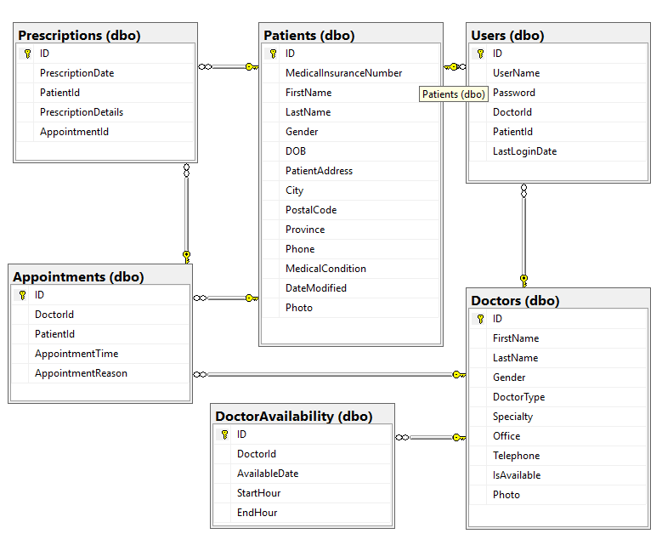

**Program Windows Drafts**

